Customer Requirements Specification

**SAG Glasses**

**ـــــــــــــــــــــــــــــــــــــــــــــــــــــــــــــــــــــــــــــــــــــــــــــــــــــــــــــــــــــــــــــــــــــــــــــــــــــــــــــــــــــــــــــــــــــــــــــــــــــــــــــــــــــــــــــــــــــــــــــــــــــــ**

**Table of Contents**

Document Status:………………………………………………………………...1 Document History:………………………………………………………………..1 Reference Document:…………………………………………………………....2 Project Description:……………………………………………………………....3

**Document Status:**

|  |  |  |
| --- | --- | --- |
| **Name** | PO_SAG_CRS_Glasses | |
| **Version** | V1.2 | |
| **Status** | Proposed | |
| **Author** | Jana Muhammed | |
| **Date** | [13-11-2022] | |
| **Team Approval** | Omnia | Approved |
| **Mentor Approval** |  |  |
| **Final Approval** |  |  |

**Document History:**

|  |  |  |  |
| --- | --- | --- | --- |
| **Version** | **Author** | **Date** | **Date Change** |
| 1.0 | Reham Essam | [28/9/2022] | ● Initial Creation |
| 1.1 | Jana Muhammed | [11/11/2022] | * Edit CRS Requirements * Edit Key Elements |

|  |  |  |  |
| --- | --- | --- | --- |
| 1.2 | Jana Muhammed | [13/11/2022] | * Edit CRS Requirements * Edit system context |

**Reference Document:**

|  |  |  |  |
| --- | --- | --- | --- |
| **Ref.number** | **Doc.Name** | **Version** | **Status** |
| 1 | PO_SAG_CR_Glasses | V1.2 | Released |

**Project Description:**

Definition:

The Design of the project is The Glasses closed around the head, between the two lenses of the Glasses there is a camera, on the right hand there is a power button , flash and mic , on the left side there are three buttons and a speaker.

Features:

* Glasses’ features can be controlled by the user through buttons.
* Glasses have two modes (Day mode - Night mode).
* Glasses can capture images.
* Glasses support the voice command.
* Glasses can speak.
* ECU protection and maintenance.

Key Elements:

* The Glasses shall have a button to turn it on/off.
* The Glasses shall have a button to control the headphone sound.
* The Glasses shall have a button to enable/disable image caption feature.
* The Glasses shall have a button to enable/disable voice commands.
* The Glasses shall detect the night/day mode using LDR.
* The Glasses shall have a camera that supports real-time capturing.
* The Glasses shall have a microphone through which it receives voice commands.
* The Glasses shall have headphones to play any audio.
* The Glasses shall keep tracking voltage and temperature level.
* The Glasses shall decrease heat using a DC fan.

System Context:

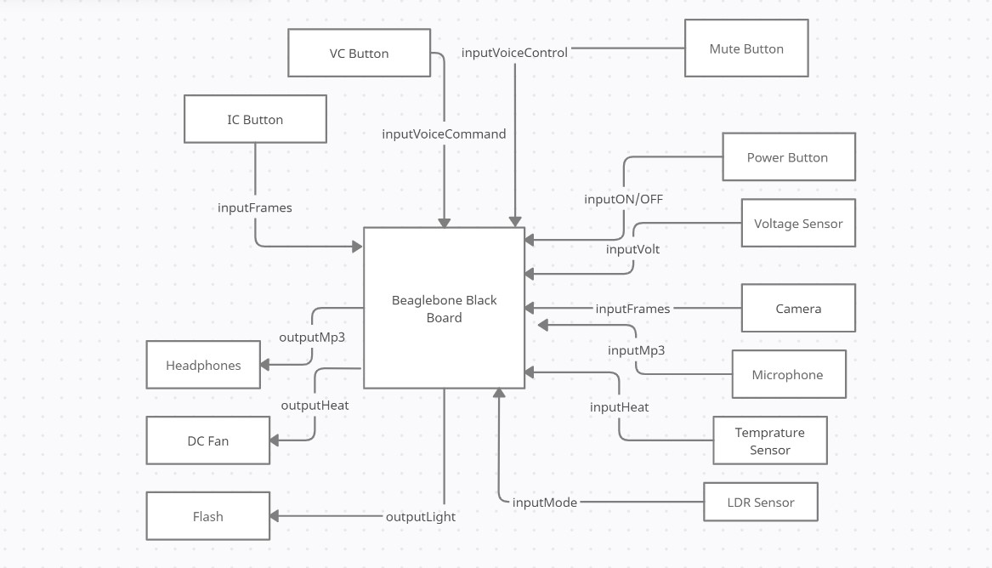

CRS Requirements:

|  |  |  |  |
| --- | --- | --- | --- |
| **Req_ID** | Req_PO_SAG_CRS_Glasses_***001***-V1.1 | **Covers** | PO_SAG_CR_Glasses_***001***-V1.0 |
| **Description** | User presses on the power button to turn the glasses on/off | | |

|  |  |  |  |
| --- | --- | --- | --- |
| **Req_ID** | Req_PO_SAG_CRS_Glasses_***002***-V1.1 | **Covers** | PO_SAG_CR_Glasses_***002***-V1.1 |
| **Description** | By pressing the sound button, the user can mute or change the sound level when the glasses begin to speak to him via the headphones. | | |
| **Req_ID** | Req_PO_SAG_CRS_Glasses_***003***-V1.1 | **Covers** | PO_SAG_CR_Glasses_***003***-V1.1 |
| **Description** | By pressing the image caption button, the user can enable or disable the glasses' ability to inform him of what is happening around him. | | |

|  |  |  |  |
| --- | --- | --- | --- |
| **Req_ID** | Req_PO_SAG_CRS_Glasses_***004***-V1.1 | **Covers** | PO_SAG_CR_Glasses_***006***-V1.1 |
| **Description** | The camera on the glasses can capture images in real time.. | | |

|  |  |  |  |
| --- | --- | --- | --- |
| **Req_ID** | Req_PO_SAG_CRS_Glasses_***005***-V1.1 | **Covers** | PO_SAG_CR_Glasses_***004***-V1.1 |
| **Description** | By pressing the VC button, the glasses receive voice commands from the user. | | |

|  |  |  |  |
| --- | --- | --- | --- |
| **Req_ID** | Req_PO_SAG_CRS_Glasses_***006***-V1.1 | **Covers** | PO_SAG_CR_Glasses_***007***-V1.0 |
| **Description** | The glasses receive the voice commands through the microphone. | | |

|  |  |  |  |
| --- | --- | --- | --- |
| **Req_ID** | Req_PO_SAG_CRS_Glasses_***007***-V1.1 | **Covers** | PO_SAG_CR_Glasses_***005***-V1.1 |
| **Description** | The LDR sensor detects the night mode and automatically turns on the flash. | | |

|  |  |  |  |
| --- | --- | --- | --- |
| **Req_ID** | Req_PO_SAG_CRS_Glasses_***008***-V1.1 | **Covers** | PO_SAG_CR_Glasses_***008***-V1.2 |
| **Description** | Headphone plays any audio (mp3 files are received from the machine learning models), the way through which the glasses talk to the user. | | |

|  |  |  |  |
| --- | --- | --- | --- |
| **Req_ID** | Req_PO_SAG_CRS_Glasses_***009***-V1.1 | **Covers** | PO_SAG_CR_Glasses_***009***-V1.0 |
| **Description** | Voltage sensor tracks the battery level and sends a signal if the battery needs to be charged. | | |

|  |  |  |  |
| --- | --- | --- | --- |
| **Req_ID** | Req_PO_SAG_CRS_Glasses_***010***-V1.1 | **Covers** | PO_SAG_CR_Glasses_***009***-V1.2 |
| **Description** | Temperature sensor measures heat of board, in case of high temperature this sensor automatically turns on the DC fan. | | |

|  |  |  |  |
| --- | --- | --- | --- |
| **Req_ID** | Req_PO_SAG_CRS_Glasses_***011***-V1.1 | **Covers** | PO_SAG_CR_Glasses_***010***-V1.1 |
| **Description** | DC fan decreases the heat of the board. | | |

nhh

jj